<!--This file created 2:29 PM 10/29/97 by Claris Home Page version 2.0-->5.9 Project
Trapezoidal and Simpson Approximations

In the Section 5.4 project we illustrated the calculator/computer calculation of Riemann sum approximations to the integral 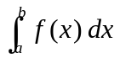 of a given function  from x = a
to x = b. Here we illustrate the combination of Riemann sums to form trapezoidal and Simpson sums.
Any Riemann sum approximating the given integral corresponds to subdivision
of the interval [a, b] into a selected number n of equal-length subintervals with successive endpoints 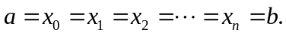 Each such subinterval 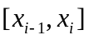 has length 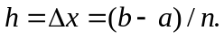 We start by calculating the left-endpoint sum

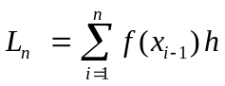 (1)

the right-endpoint sum
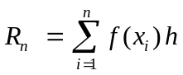 (2)
and the midpoint sum
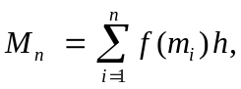 (3)

where 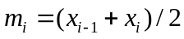 is the midpoint of the ith subinterval . We can then proceed immediately to calculate first the trapezoidal sum

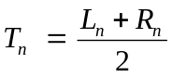 (4)
and then the Simpson sum

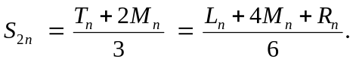 (5)

Note that the left-endpoint, right-endpoint, and midpoint sums with n subintervals yield the Simpson sum corresponding to a subdivision of [a, b] into twice as many subintervals. We illustrate below the calculation of the sums in (1)–(5) using the particular integral
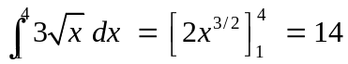 (6)

with known exact value.
Using a Graphing Calculator
In order to calculate sums with a TI graphing calculator, we need only know the command

sum(seq(expression, variable, begin, end, increment))
for calculating the sum of the "sequence" (or list) of numbers obtained by substituting the successive values begin, begin+increment, begin+2*increment, . . . . ., end for the "variable" in the "expression". On the TI-83 calculator the sum command is found in the 2nd LIST MATH menu and the seq command in the 2nd LIST OPS menu. On the TI-86 calculator both are found in the 2nd MATH MISC menu.

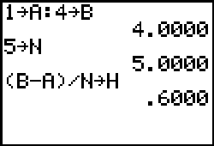

This TI-83 screen shows a calculator prepared to calculate Riemann sums for the Y= menu function Y1 = 3*X^(1/2) on the interval [1, 4] with n = 5 subintervals each of length h = (b - a)/n. The following screen now shows the calculation of the left-endpoint and right-endpoints sums L and R. Note how we get the left-hand sum by starting the sum at the left endpoint A of the first subinterval, and the right-hand sum by starting at the right endpoint A+H.

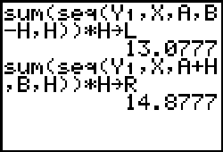

We calculate the midpoint sum M similarly, and then the averages that define the trapezoidal sum T with n = 5 subintervals and the Simpson sum S with 2n = 10 subintervals:

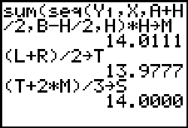

To whether we've actually got the exact value of the integral, we set our calculator to MODE Float 8 and re-execute the final command:

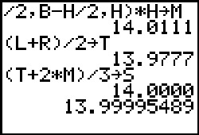

Thus the best we can say at this point is that Simpson's approximation with 10 subintervals is 13.999955 accurate to 6 decimal places. But knowing that our commands are "working", we can quickly double the number of subintervals and repeat the calculations. (Indeed, no further typing is necessary, as each command above can be retrieved with the 2nd Enter key.)

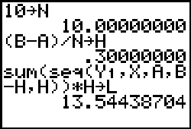

Our final screen looks like this:

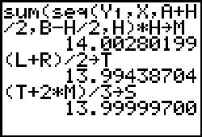

Thus the Simpson sum with 20 subintervals is 13.999997 accurate to 6 decimal places. Finally, we can ask our calculator to use it's own more sophisticated internal numerical integration method:

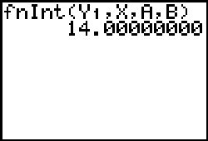

The fnInt command is found in the MATH menu on the TI-83 and in the 2nd CALC menu on the TI-86.

In order to approximate a different integral, you need only define the desired integrand function Y1=f(x) and re-enter the sequence of commands shown above, starting with the desired limits a and b and number n of subintervals.

Using Maple

For an illustrative example, we consider numerical approximation of the integral

Int(3*sqrt(x), x=1..4 ) = int(3*sqrt(x), x=1..4 );
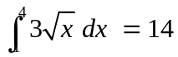

with known exact value 14, given integrand function

f := x -> 3*sqrt(x):

and limits

a := 1: b := 4:

and with 15-digit precision

Digits := 15:

If we start with

n := 5:

subintervals each having length

h := (b - a)/n:

then the ith subdivision point is defined by

x := i -> a + i*h:

and the endpoints of the ith subinterval are x(i-1) and x(i).

With this setup, the following computations will result in the Simpson sum S corresponding to a subdivision of the interval [a, b] into the doubled number 2n of subintervals. We calculate first the left-endpoint sum L and the right-endpoint sum R.

L := evalf(sum( f(x(i))*h, i=0..n-1 ));
L := 13.0776834708238

R := evalf(sum( f(x(i))*h, i=1..n ));
R := 14.8776834708238

The midpoint of the ith subinterval is given by

m := i -> (x(i-1)+x(i))/2:

so the midpoint sum with n subintervals is

M := evalf(sum( f(m(i))*h, i=1..n ));
M := 14.0110906009057

Next we average the left-endpoint and right-endpoint sums to calculate the trapezoidal sum

T := (L + R)/2;
T := 13.9776834708238

with n subintervals. Finally we calculate the weighted average of the midpoint and trapezoidal sums that yields the Simpson sum with 2n subintervals.

S := (T + 2*M)/3;
S := 13.9999548908784

Rounded off to 6 decimal places, Simpson's approximation with 10 subintervals is 13.999955.

The command

evalf( Int(f(x), x=1..4), 25);
14.00000000000000000000000

asks Maple to do its best, carrying 25 digits internally. It uses a numerical technique that is somewhat more sophisticated and accurate than Simpson's method.

Using Mathematica

For an illustrative example, we consider numerical approximation of the integral

Integrate[3*Sqrt[x], {x, 1, 4}]
14

with known exact value 14, given integrand function

f[x_] := 3 Sqrt[x]

and limits

a = 1; b = 4

If we start with

n = 5;

subintervals each having length

h = (b - a)/n;

then the ith subdivision point is defined by

x[i_] := a + i*h

and the endpoints of the ith subinterval are x[i-1] and x[i].

With this setup, the following computations will result in the Simpson sum S corresponding to a subdivision of the interval [a, b] into the doubled number 2n of subintervals. We calculate first the left-endpoint sum L and the right-endpoint sum R with 20-digit accuracy.

Sum[f[x[i-1]]*h, {i,1,n}];
L = N[%, 20]
13.077683470823783185

Sum[f[x[i]]*h, {i,1,n}];
R = N[%, 20]
14.877683470823783185

The midpoint of the ith subinterval is given by

m[i_] := (x[i-1] + x[i])/2

so the midpoint sum with n subintervals is

Sum[f[m[i]]*h, {i,1,n}];
M = N[%, 20]
14.011090600905693381

Next we average the left-endpoint and right-endpoint sums to calculate the trapezoidal sum

T = (L + R)/2
13.977683470823783185

with n subintervals. Finally we calculate the weighted average of the midpoint and trapezoidal sums that yields the Simpson sum with 2n subintervals.

S = (T + 2 M)/3
13.999954890878389982

Rounded off to 6 decimal places, Simpson's approximation with 10 subintervals is 13.999955.

The command

NIntegrate[f[x], {x, a, b}, WorkingPrecision -> 20]
14.000000000

asks Mathematica to do its best, carrying 20 digits internally. It uses a numerical technique that is somewhat more sophisticated and accurate than Simpson's method.

Using MATLAB

First we define the integrand function

f = inline('3*sqrt(x)');

of our integral 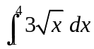 with known exact value 14 and limits given by

a = 1; b = 4;

If we now start with
n = 5;
subintervals each having length
h = (b - a)/n;
then the successive endpoints of these n subintervals are the n+1 elements of the vector
x = a : h : b
x =
1.0000 1.6000 2.2000 2.8000 3.4000 4.0000
The left endpoints of these subintervals are
xL = x(1:n)
xL =
1.0000 1.6000 2.2000 2.8000 3.4000
The right endpoints are
xR = x(2:n+1)
xR =
1.6000 2.2000 2.8000 3.4000 4.0000
And the midpoints of these n subintervals are
xM = (xL + xR)/2
xM =
1.3000 1.9000 2.5000 3.1000 3.7000
Using the MATLAB function sum(v) that calculates the sum of the elements of the vector v, we can now calculate immediately the left-endpoint, right-endpoint, and midpoint sums for the function f(x) on the interval [a, b]:
L = sum(f(xL)*h)
L =
13.0777
R = sum(f(xR)*h)
R =
14.8777
M = sum(f(xM)*h)
M =
14.0111
We can now proceed to the trapezoidal sum
T = (L + R)/2
T =
13.9777
with n subintervals and the Simpson sum
S = (T + 2*M)/3
S =
14.0000
To check whether we've really got the exact result 14, we can ask for full double precision:
format long
S
S =
13.99995489087839
Rounded off to 6 decimal places, Simpson's approximation with 10 subintervals is 13.999955.

The MATLAB command quad(f,a,b,tol) employs a more sophisticated numerical method to approximate the desired integral of  from to 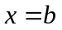 with a "relative error" of tol. For instance, we get
quad(f,1,4,1e-4)
ans =
13.99999013131382

quad(f,1,4,1e-8)
ans =
13.99999999990862
This gives the value 14.000000000 accurate to 9 decimal places.

